< Bryn Dunbar >

< 2020-Feb-24 >

< IT FDN 100: Foundations of Programming (Python) >

< Assignment 05 >

Modify an existing script to replace the inner data structure to dictionaries; add ability to load existing data, and to delete an entry

# Introduction

The task of Assignment 05 is to modify an existing script by replacing the inner data structure of lists to dictionaries. The assignment also requires the added functionality of loading existing data and of deleting an entry in a dictionary.

# Topic 1

One of the components of the assignment was to replace the inner data structure to dictionary form. I had to convert an existing list to a dictionary. In the ‘Declare variables’ section of the starter script, I added a variable called **dicRow** and assigned the curly brackets to the variable. This made an empty dictionary.

In the ‘Add Data’ section of the script, I deleted the item referring to **lstRow** and added data via a dictionary type to my **dicRow** variable.

Figure – Replacing a List with a Dictionary

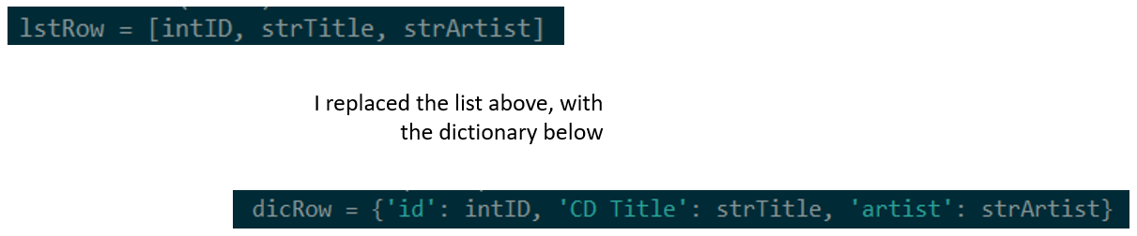

After replacing the list with a dictionary, I appended my new dictionary to the outer data structure list called **lstTbl**. I did this by calling **dirRow** instead of **lstRow** for the append method.

For the ‘Display Data (*i*) and ‘Save Data’ (*s*) sections, I used the **values()** method, in my inner for loops, to get a list of the dictionary row values. This allowed me to access all the values in each dictionary (each cd) and display them for choice *i* and save them to a file for choice *s*.

Using [PlanetB’s](http://www.planetb.ca/syntax-highlight-word) (external reference web page) [1]

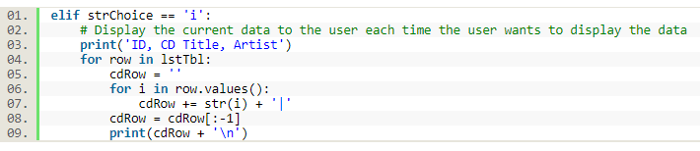

Using [PlanetB’s](http://www.planetb.ca/syntax-highlight-word) (external reference web page) [2]

LISTING 1 – Section i of script: Display Data – Showing the use of the values() method

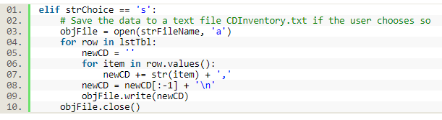

LISTING 2 – Section s of script: Saving Data to a File – Showing the use of the values() Method

# Topic 2

Loading existing data into my script was a TODO task within this assignment. In the video for Module 5, Part 2, I learned how to do this. In this section of the script, I accessed a text file using the read mode. I created a list (**lstRow**) referring to each row of the text file. For this list, I used the **strip() method** to remove whitespaces and used the split method to split my list elements by a comma. Then I created a dictionary out of the list elements. Other than some finishing touches with print statements, I completed this section by appending the dictionary to the out list (the CD Inventory List).

Using [PlanetB’s](http://www.planetb.ca/syntax-highlight-word) (external reference web page) [3]

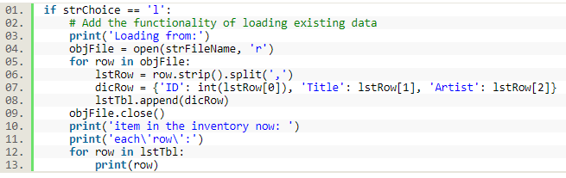

LISTING 3 – Loading data from a File into Script

# Topic 3

The last TODO task was to add the functionality of deleting an entry in a dictionary. In order to accomplish this goal, I used the **values()** method again to access the values of my dictionary in the inner for loop. In this section, I ask the user to enter an ID of CD to delete, then using the **if - in** conditional statement, I tell the program to delete the CD, or dictionary row, if the ID exists in the dictionaries within the CD Inventory (represented as **lstTbl**).

Using [PlanetB’s](http://www.planetb.ca/syntax-highlight-word) (external reference web page) [4]

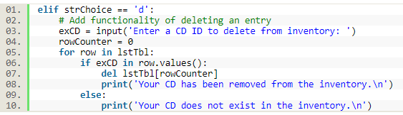

LISTING 4 – section of script for Deleting an Entry of the CD Inventory

# Summary

The goal of this assignment was to ask a user to choose items in a menu; load data from a file, add data to a CD Inventory, display CD Inventory Data, delete an entry of the CD Inventory, or save the CD Inventory data to a file. I believe that I have accomplished this task:

Figure 2 – Image of Working Script in Spyder

Figure 3 - Image of Working script in Anaconda Terminal

# Appendix

Using [PlanetB’s](http://www.planetb.ca/syntax-highlight-word) (external reference web page) [5]

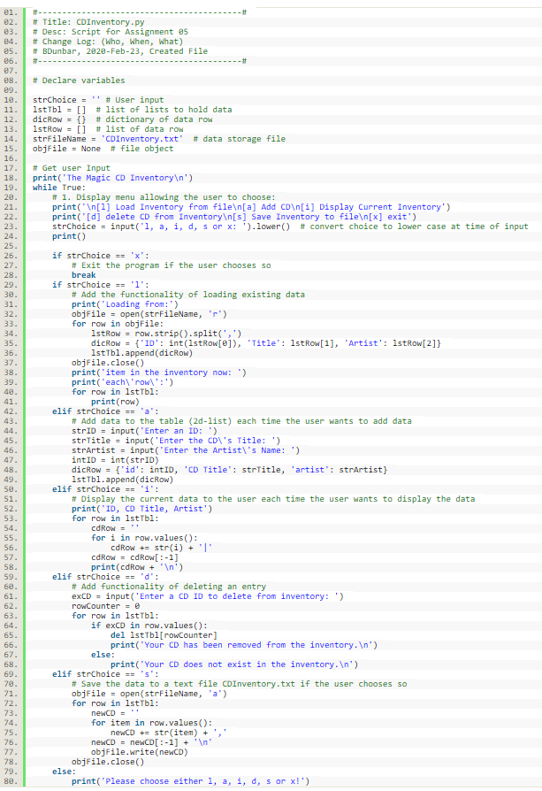

Listing 4 - Source Code

1. <http://www.planetb.ca/projects/syntaxHighlighter/popup.php> - retrieved 24-Feb-20
2. <http://www.planetb.ca/projects/syntaxHighlighter/popup.php> - retrieved 24-Feb-20
3. <http://www.planetb.ca/projects/syntaxHighlighter/popup.php> - retrieved 24-Feb-20
4. <http://www.planetb.ca/projects/syntaxHighlighter/popup.php> - retrieved 24-Feb-20
5. <http://www.planetb.ca/projects/syntaxHighlighter/popup.php> - retrieved 24-Feb-20